**Cab Transaction Using Facial Recognition and Matching Engine**

B.E. Phase I project report submitted in partial fulfilment of the requirements of the degree of

**Bachelor of Engineering**

by

**Kshitij Shukla (EU2152053)**

**Rohan Chavan (EU1152082)**

**Saniket Patil (EU2152014)**

Under the guidance of

**Mr. Vivian Lobo**



**Department of Computer Engineering**

**St. John College of Engineering and Management**

**University of Mumbai**

**2019-2020**

CERTIFICATE

This is to certify that the project entitled **“Cab Transaction Using Facial Recognition and Matching Engine”** is a Project Phase I report of

**Kshitij Shukla (EU2152053)**

**Rohan Chavan (EU1152082)**

**Saniket Patil (EU2152014)**

Submitted to University of Mumbai in partial fulfilment of the requirement for the award of the degree of **“Bachelor of Engineering”** in **“Computer Engineering”.**

ii

Project Report Approval for B. E.

This project synopsis entitled **Cab Transaction Using Facial Recognition and Matching Engine** by Kshitij Shukla, Rohan Chavan, Saniket Patil is approved for the degree of **Bachelor of Engineering** in **Computer Engineering** from **University of Mumbai**.

Examiners

**1.--------------------------------**

**2.--------------------------------**

Date:

Place:

iii

**Abstract**

Currently when you book a Cab, at the end of the ride you make the transactions with either cash or Card/UPI/E-Wallet. Sometimes these methods are not hassle-free as they cause inconvenience to the customer. We propose a new System for transactions in Cabs, where your face is your Transaction method. The system in the Cab will calculate your fare based on the distance and then it will authenticate your face and transact via the connected central database.

Face Recognition begins with extracting the coordinates of features such as width of mouth; width of eyes, pupil, and compare the result with the measurements stored in the database and return the closest record (facial metrics).

Main purposes of this research is to research different types of face recognition algorithms like Eigen face and Fisherface. Open CV provides these recognition algorithms. We do this by comparing the Receiver Operating Characteristic Curve to implement it in our Transaction using Facial Recognition.

We have noted that EigenFace delivers better results than the Fisherface algorithm, Eigen face delivers between 70 to 80 % accuracy between faces.

If the User’s input image matches with the trained dataset image then the User Profile and Transaction details will be loaded, and the subsequent trip details will be stored in the User Profile database. The database is connected to FRaME web server. The system has 95% accuracy with the dataset of 20 person images.

**Chapter 1**

**Introduction**

With the popularity in India of mobile payment platforms such as Paytm and PhonePe, QR codes can be found almost anytime, anywhere in Indian daily life. From luxury shopping centers to street vendors, consumers can make payments easily by scanning a QR code with their smartphones. The awkwardness of forgetting your wallets at home no longer exists. As long as you have a mobile payment set up on your phone, you can virtually always go cashless in India.

But, things are changing as we speak. QR codes are just a step in the evolution of mobile payment technology and they may soon be a thing of the past. In fact, soon people in India may be able to forget about QR codes, and pay with virtually nothing but... themselves. This new payment method we are talking about is facial recognition, which we are planning to implement in Cabs.

**How does facial recognition work?**

Using a series of algorithms, facial recognition technology works by scanning your face using a digital camera, analyzing it based on a variety of physical traits. Using this analysis, the system can create a faceprint - a unique code of individual face, which is stored and accessed through an identity database.

**Chapter 2**

**Review of Literature**

Literature Review acts as the basis of research and study of the various concepts required for a particular domain. It describes the theories and other methodologies that can be adopted in order to implement modules of the proposed system. This chapter includes literature survey of technical papers along with the advantages and disadvantage of each system.

**2.1 Face Recognition Techniques for Differentiate Similar Faces and Twin Faces [3]**

In computer technology image based on identical twin face recognition

technology is challenging task. Traditional facial recognition system exhibit

poor performance in differentiating identical twins and similar person under practical conditions. The following methods for differentiate identical twins.

Traditionally lot of manual experiments were performed to identify twins and also to recognize their features with difference, and many more systems were existed to show differences in twins by using finger prints, voice and iris as part of pattern recognition. In existing methods many techniques are used for twin’s identification like finger print, voice and iris recognition. The process of finger print identification is used to identify unique person in industry or organizations.

The method propose a scan image taken from the person and compare with database for identification. The iris recognition also similar method to finger prints identification.

**FACIAL RECOGNITION TECHNOLOGY:**

Facial Recognition technology s biometric identification by scanning a human face and matching with stored database images. Face recognition system can be used for identification and verification of a person.

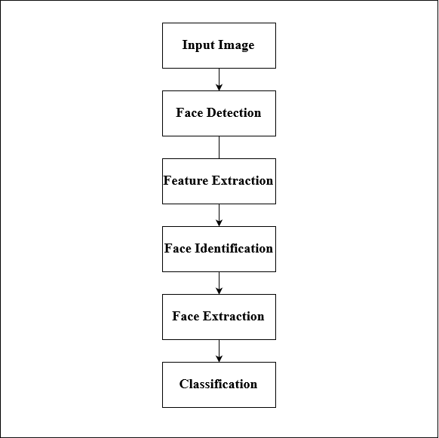

Figure 2.1: System Architecture for Face Recognition Technology